Project Design Phase-II
Technology Stack (Architecture & Stack)

Date | 27 Feb 2026
Team ID | LTVIP2026TMIDS81127
Project Name | Your Center for Skill Enhancement
Maximum Marks | 4 Marks

Technical Architecture:
A technical architecture shows the structure of your system, including how users, processes, databases, and external services interact. This ensures clarity on components, data flow, and integrations. Example: Order processing during pandemics for offline mode
Reference: https://developer.ibm.com/patterns/ai-powered-backend-system-for-order-processing-during-pandemics/
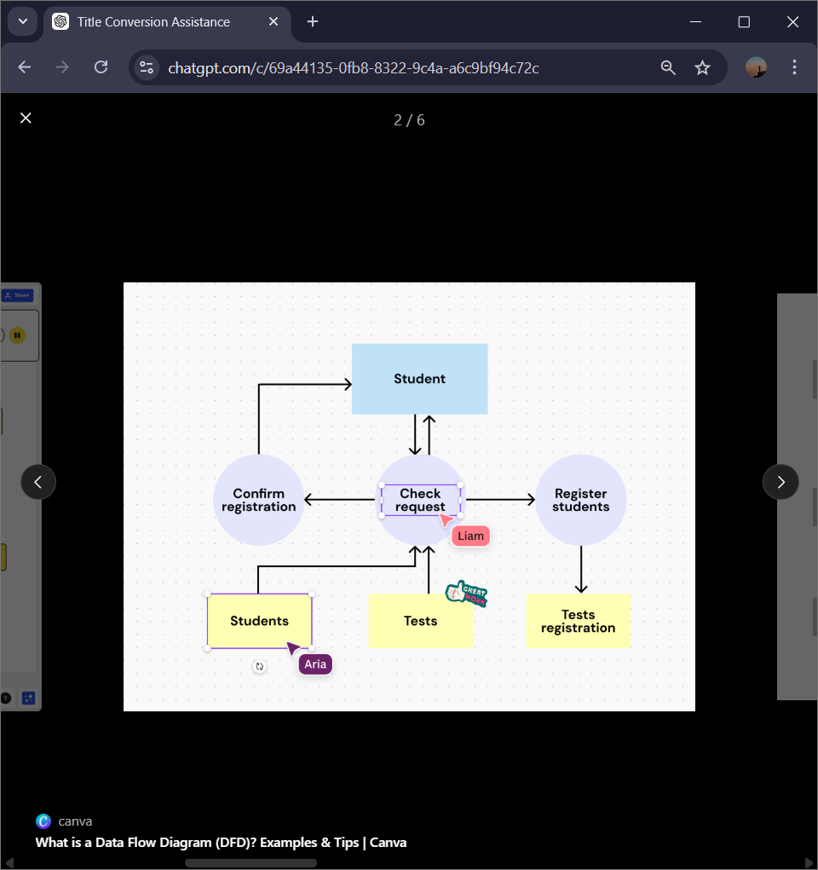
Guidelines:
Include all the processes (As an application logic / Technology Block)
Provide infrastructural demarcation (Local / Cloud)
Indicate external interfaces (third party API’s etc.)
Indicate Data Storage components / services
Indicate interface to machine learning models (if applicable)
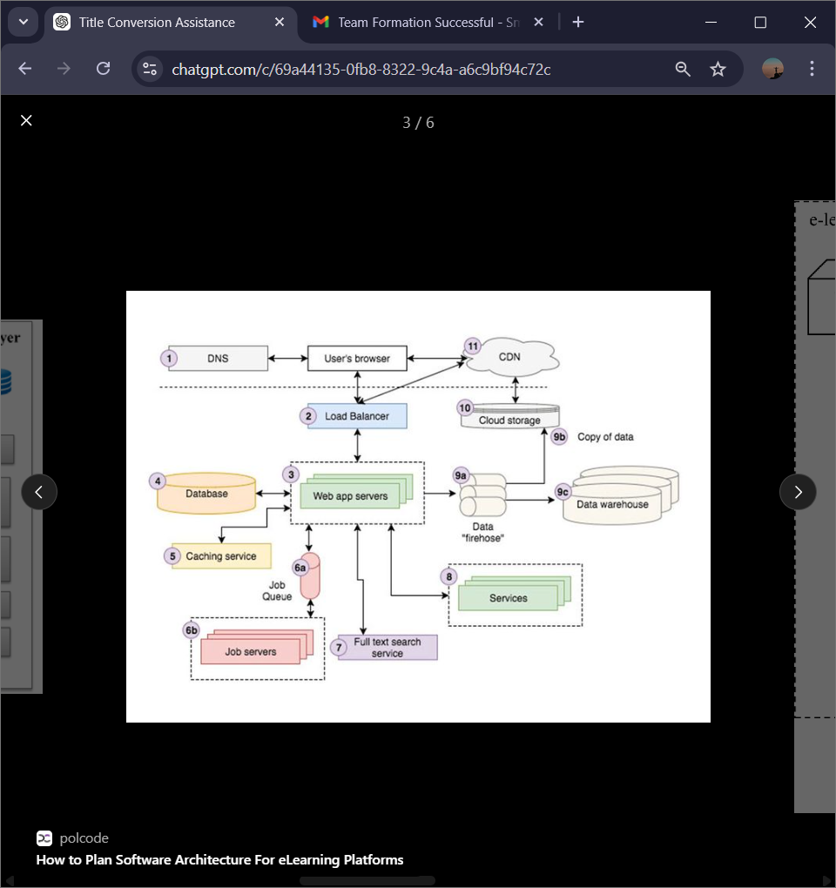

Table-1 : Components & Technologies:
S.No | Component | Description | Technology
 | Frontend | React.js/React Native | Provides UI for students, trainers, and admins
 | Backend | Node.js /Python Flask | Handles APIs, business logic, and data processing
 | Database | MySQL /MongoDB | Stores user, course, assessment, and admin data
 | Authentication | oAuth2.0 | Secure login and role-based access control
 | Cloud Hosting | Aws. | High availability, scalability, and hosting
 | Notifications | Firebase | Email and push notifications for updates
 | Analytics | Google Analytics | Tracks user engagement and course completion
Application Characteristics:
The application is designed to be user-friendly, scalable, and robust, ensuring students, trainers, and administrators can efficiently interact with the system. Below are the key characteristics:
1. User-Centric
- Designed with intuitive navigation and responsive UI for students, trainers, admins, and customer care executives.
- Personalized dashboards display relevant courses, progress, and notifications.

2. Scalability
- Supports increasing numbers of users, courses, and assessments without performance degradation.
- Cloud-based deployment allows horizontal scaling as demand grows.

3. Security
- User authentication via OAuth 2.0 / JWT for secure login.
- Role-based access control ensures data privacy.
- Sensitive data is encrypted in transit and at rest.

4. Performance
- Fast loading of courses, videos, and assessments.
- Optimized backend queries and caching for smooth experience.
- Minimal downtime ensures learning continuity.

5. Reliability
- Continuous monitoring ensures the system is consistently available.
- Automated backup and recovery for user and course data.

6. Availability
- 24/7 access for students worldwide.
- Multi-device support: Web, Android, and iOS apps.

7. Maintainability
- Modular architecture allows easy updates to courses, assessments, or platform features.
- Clean coding standards enable quick debugging and enhancements.

8. Interoperability
- Integrates with email services, payment gateways, and analytics tools.
- Can communicate with third-party APIs (e.g., LinkedIn, Google for login).

References:
https://c4model.com/
https://developer.ibm.com/patterns/online-order-processing-system-during-pandemic/
https://www.ibm.com/cloud/architecture
https://aws.amazon.com/architecture
https://medium.com/the-internal-startup/how-to-draw-useful-technical-architecture-diagrams-2d20c9fda90d

